1.CREATE A TABLE MANUAL OR

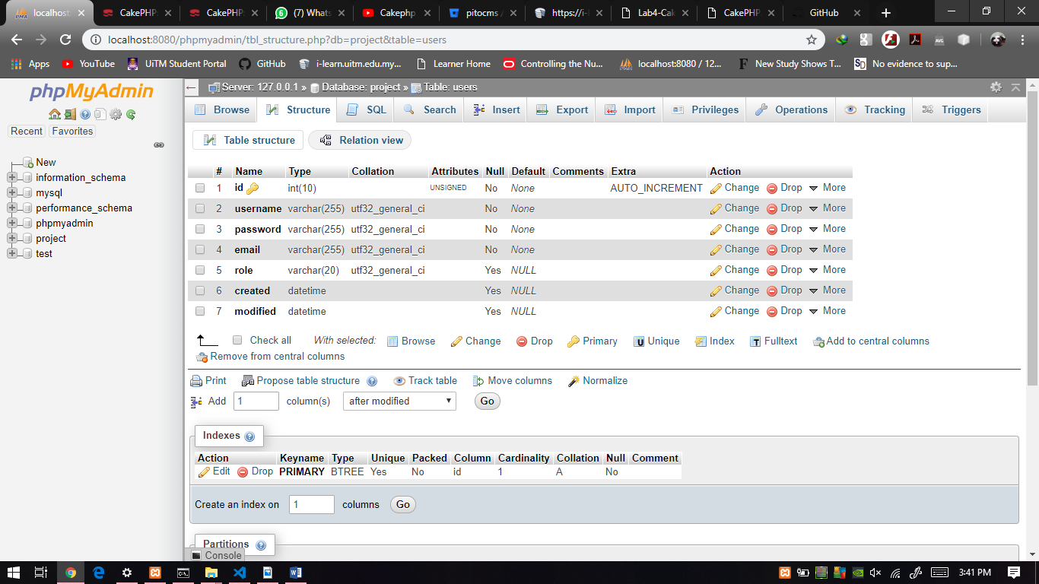

2.CREATE A TABLE WITH SQL COMMAND

|  |
| --- |
| CREATE TABLE users (  id INT(10) UNSIGNED NOT NULL AUTO_INCREMENT PRIMARY KEY,  username VARCHAR(12) NOT NULL,  password VARCHAR(255) NOT NULL,  email VARCHAR(255) NOT NULL,  role VARCHAR(20) NOT NULL,  created DATETIME,  modified DATETIME  ) ENGINE=InnoDB DEFAULT CHARSET=utf32; |

3. OPEN THE FOLDER & OPEN APP.PHP

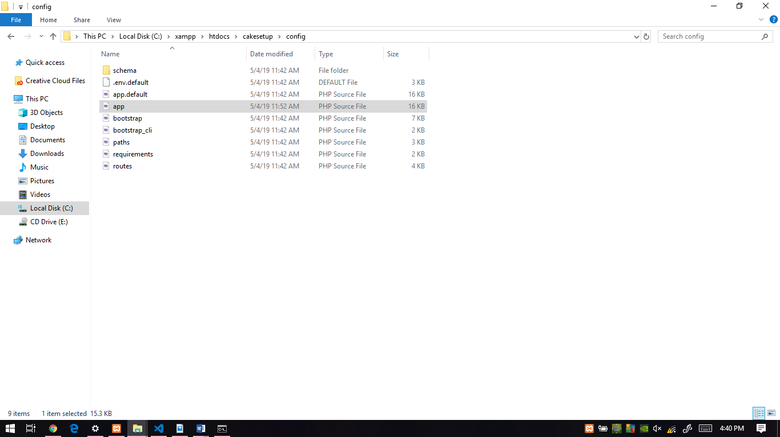

4.JUSTCHANGE IN LINE 258,259,260 LIKE THAT

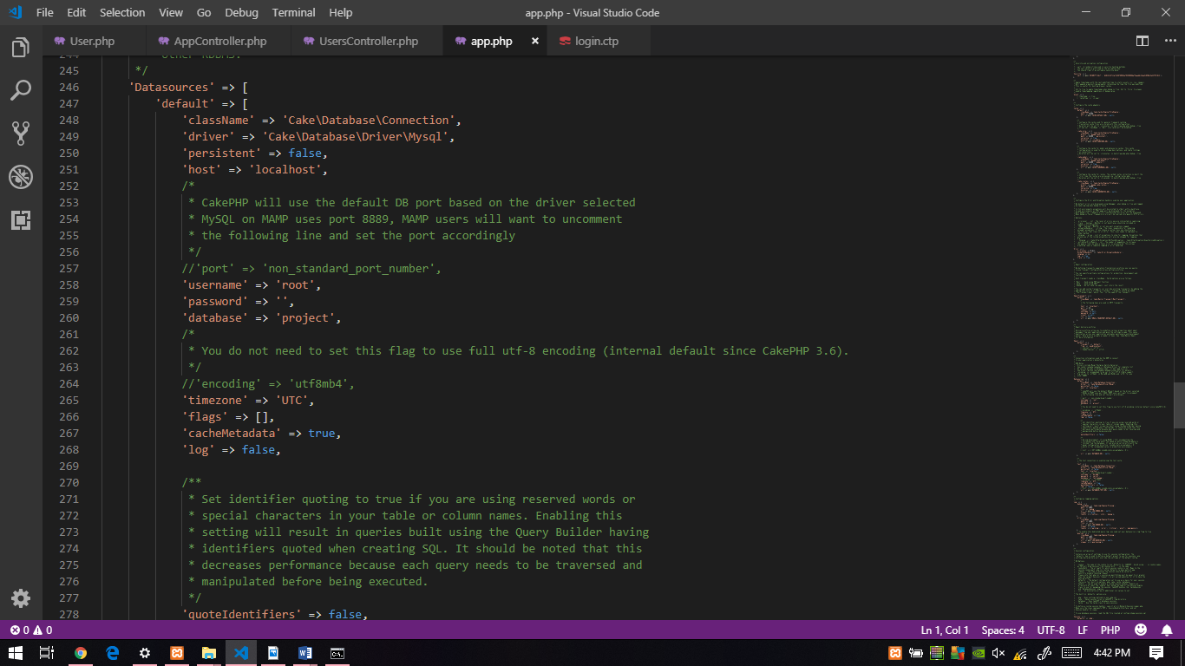

5.OPEN CMD & RUN COMMAND

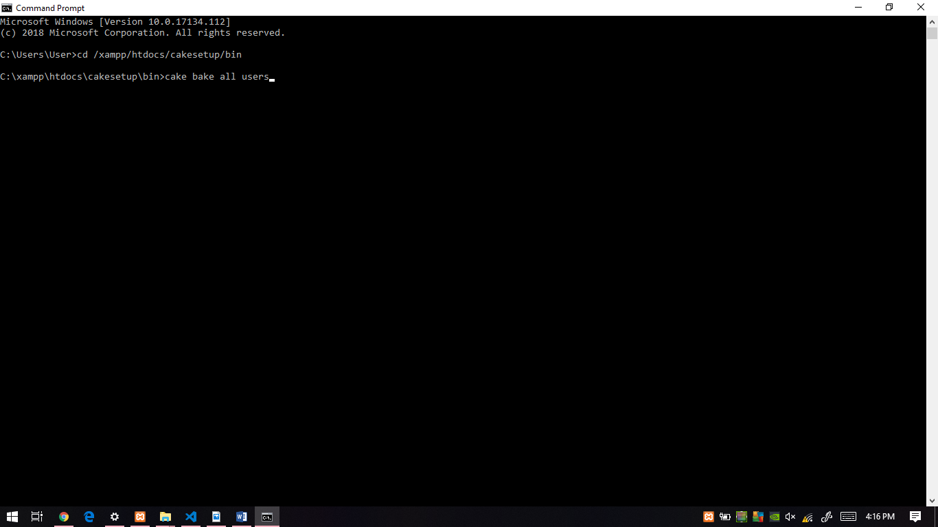 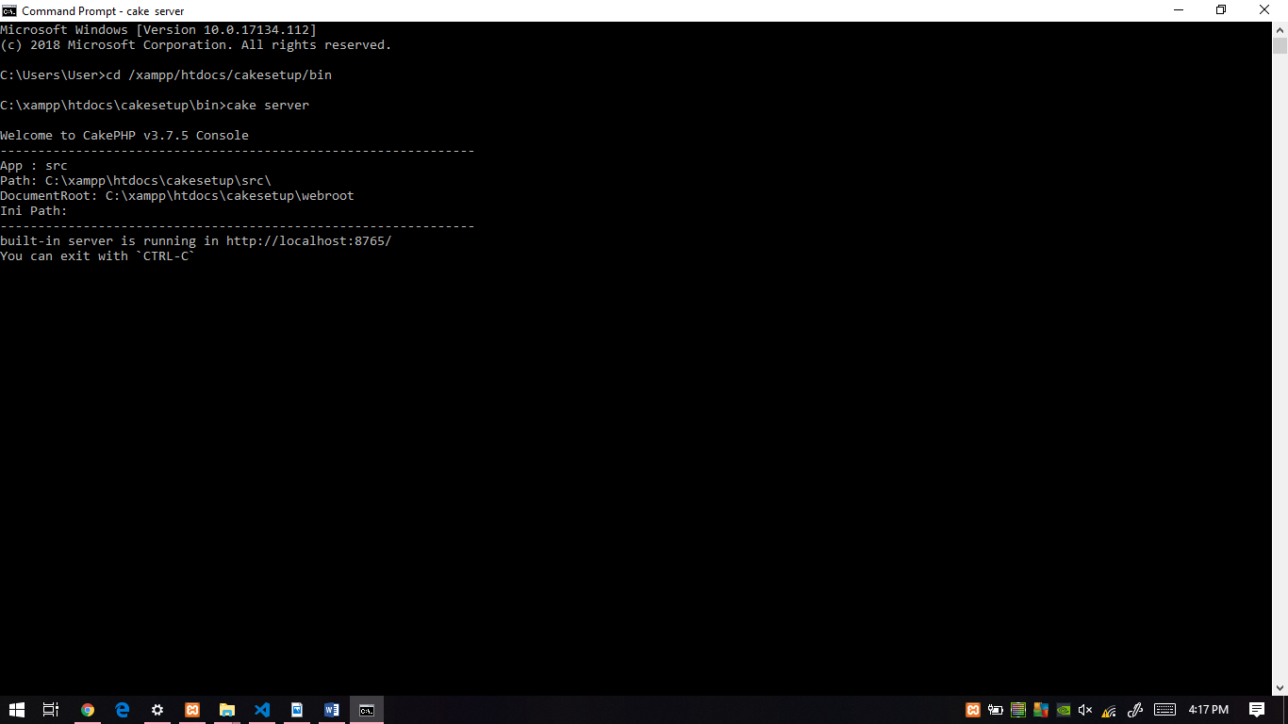

6.OPEN BROWSER & RUN <http://localhost:8765/users>

7.CREATE NEW USER & SUBMIT

